CSC 340.03

Kayvaun Khoshkhou 920357344

Assignment Zoom

Due 08/31/2020 11:55 PM

Part A:

Information on iLearn about Zoom:



This is the Zoom room with Participants Tab open

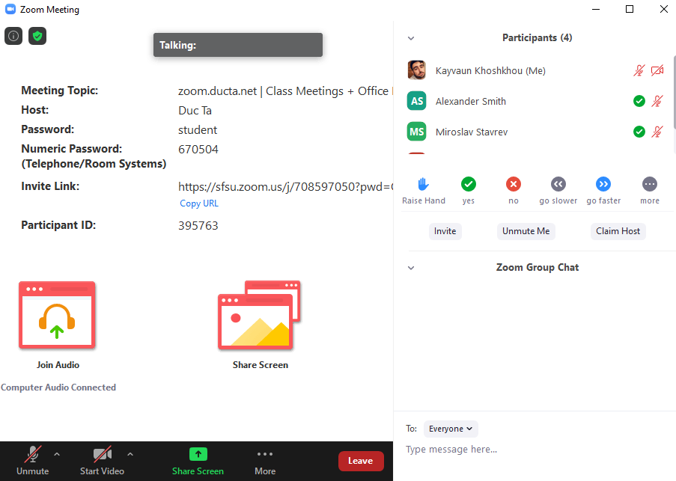



Part B:

I will regularly check iLearn and my school email for announcements, notifications, and updates from our grader, classmates, and course instructor.

I will have the shared packages and other shared materials ready and open prior to each class meeting.

Part C:

I will process all the new materials posted on the File Manager, especially under the directory “ClassMettings-on-ZOOM” prior to each class meeting.

Here is the screenshot of “ClassMettings-on-ZOOM” directory:

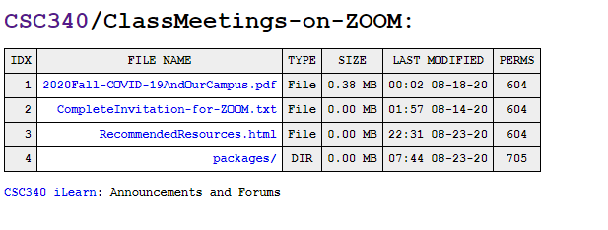

Part D:

Zoom features I believe will be useful are:

1. The yes/no feature to get quick tallies of yes/no questions the professor asks.
2. The share screen function to get efficient sharing and help.
3. Raise hand feature to get the professors notification actually will get the professors attention.
4. Clear communication allows everyone to understand what’s being said, unlike in real classrooms where sometimes things are said but not everyone hears or perhaps mishears.
5. Direct messaging allows students to ask others/communicate while in class without having to interrupt the lecture.

If Zoom hired me to improve their application I would most likely incorporate more features geared towards quizzing and questioning. Something like a poll or a pop quiz option for the professor to get a quick response from the class when there is a divide. I feel like if lectures drag on too long, students lose interest and distract themselves (as I’ve been guilty of before). If however there are engaging activities taking place it will keep me focused. If a professor wants to do something like this right now, they would have to get access to a 3rd party company or program that would let them do something like that. Zoom doesn’t have that feature as far as I know.